**Feedback Management System Documentation**

1. **Login Page :**

We can login as a Admin and Student role. We can do rolebased login.

For login User Name is Email Id and Password is PRN number.

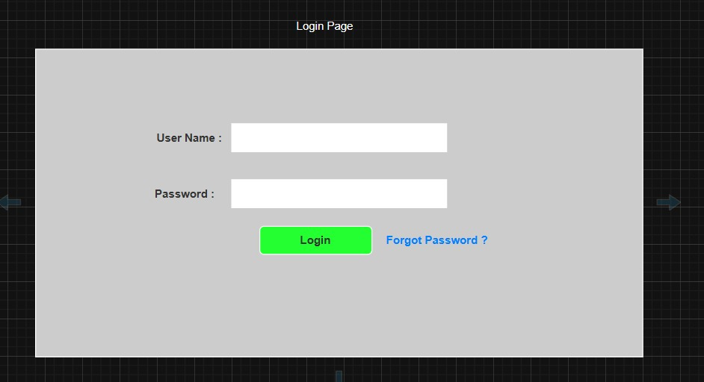

1. **Forgot Password :**

* User set forgot password
* User Name is Email Id

1. **Feedback Dashboard :**

* All added feedback listed here.
* Also you can filter Feedback as per your requirement
* Admin can update and delete feedback

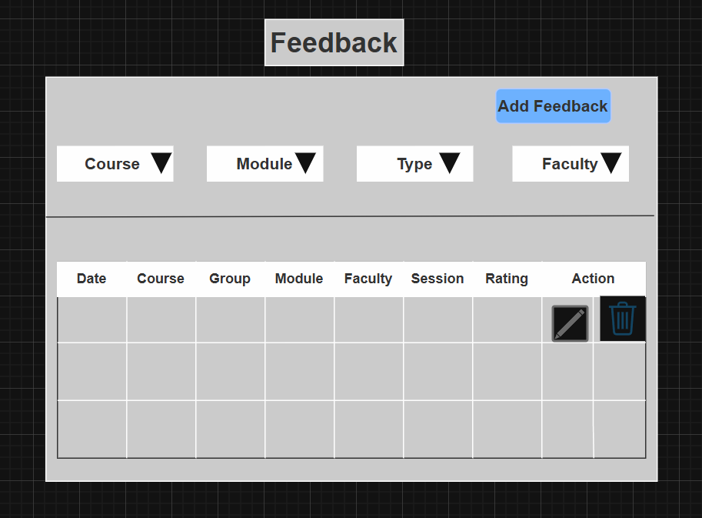

1. **Feedback Type Form:**

* Here we design a feedback type form for endmodule,mid module
* We give title as whether type of form is end module or mid module according to that we give description
* We select course for eg.k-dac-feb-25,k-dmc-feb-25 according to course we select respective module for eg.Dot Net,Java
* After selecting course we select group as
* a) Single - Theory
* b) Multiple- Lab- if we select multiple according to that batch is allocated
* we can select session yes or no and behaviour of feedback type form that is compulsory or optional
* we have given add questions button to add questions and after clicking on add questions we can see add questions window after adding questions we can view questions in our form and submit the form.
* Also can update and delete questions

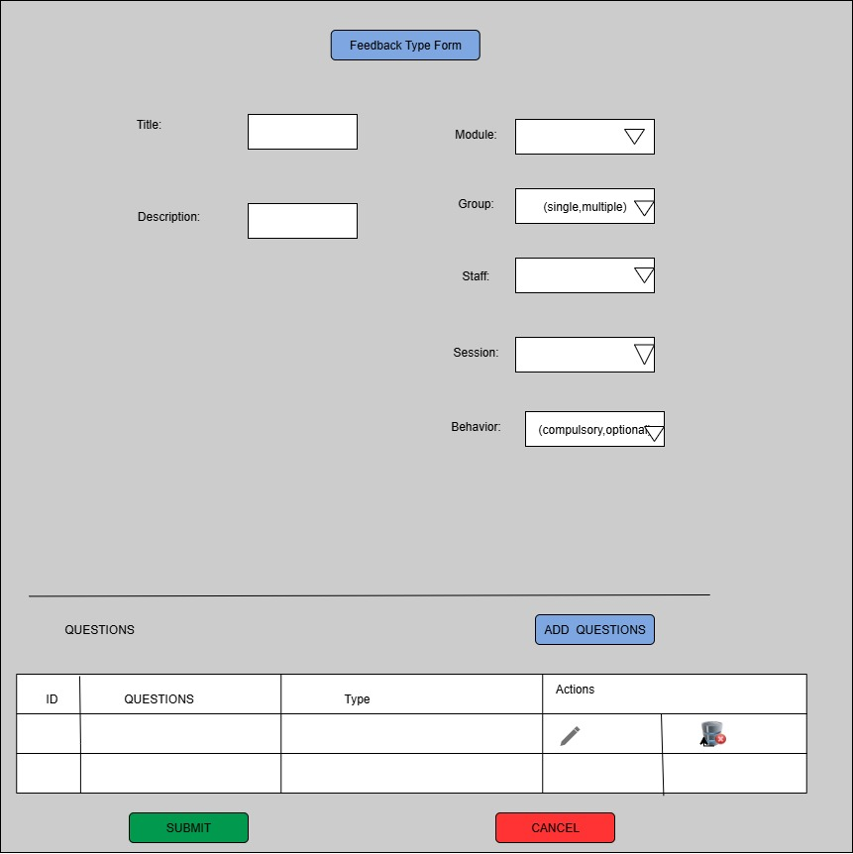

1. **Add Question :**

It is used for adding new questions into the system.

Question:-

Allows the user to type the question they want to add.

Type:-

Options:

- DESCRIPTIVE (for long answer questions)

- RADIO TYPE (for multiple choice questions)

Allows the user to select the format of the question.

---Add Button---

Submits the question and its type to be added to the system/database.

----Cancel Button-----

Cancels the current input and navigates the user back or clears the fields.

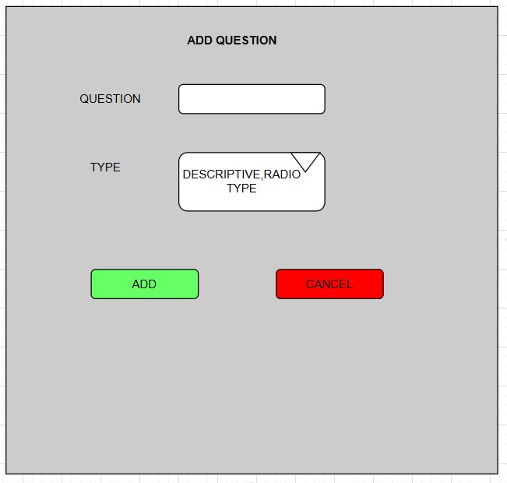

1. **Feedback Type List**

This is Feedback Type List Page.

In this page we can show all information of FeedBackType

List in tabular format.

And there is one button Add Feedback Type after clicking

on it we can redirect to FeedbackType Form

There is Action Column, where we can edit or delete FeedbackType

Form

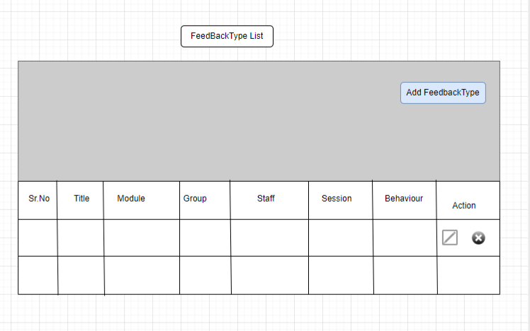

1. **Schedule Feedback List**

SCHEDULE FEEDBACK LIST

Displays a list of all scheduled feedback entries for courses and modules.

2. Schedule Feedback Button

Allows the user to schedule a new feedback session.

3. Feedback List Table

The table displays scheduled feedback entries with the following columns:

COURSE: Name of the course related to the feedback.

MODULE: Specific module or subject under the course.

TYPE: Type of feedback (e.g., Descriptive, Radio Type).

SESSION: Indicates the session.

FROM TO (DATE): The start and end date range for which the feedback is active.

STATUS (Active-Inactive): Indicates whether the feedback schedule is currently active or inactive.

FILLED BY: Shows how many participants have filled the feedback.

REMAINING: Number of participants who have not yet filled the feedback.

ACTION: Contains icons for actions such as edit and delete .

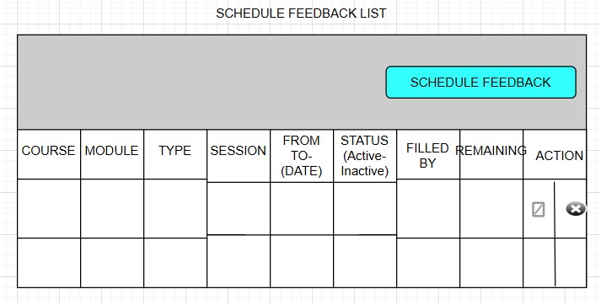

1. **Student List**

STUDENT LIST:

Displays a list of students related to a specific feedback title (either filled or remaining).

TITLE

Dynamically displays the header such as “Filled Student List” or “Remaining Student List”.

Student List Table

The table displays the list of students in the following format:

ROLL NO.: Unique roll number assigned to each student.

FIRST NAME: Student’s first name.

LAST NAME: Student’s last name.

EMAIL ID: Student’s email address.

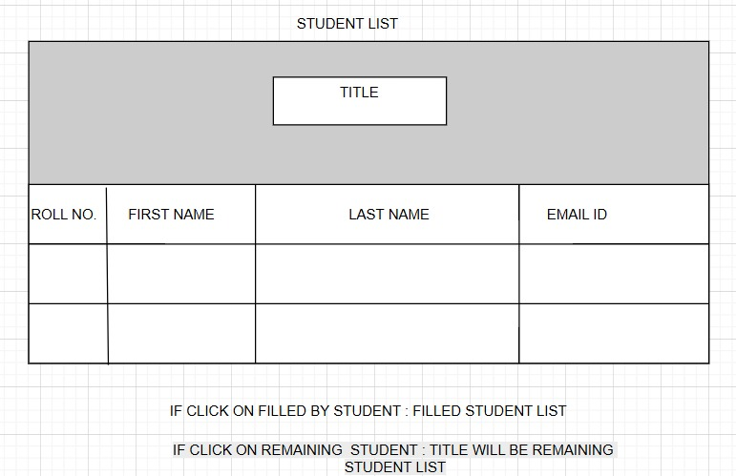

1. **Schedule Feedback Form**

Shedule feedback

Here we can schedule the feedback we have given the section from this date to date that feedback is available

In Type section we can select mid module or end module

We can select module for eg dot net

And course like dac

We can select staff name and group like single or multiple

We can select session count

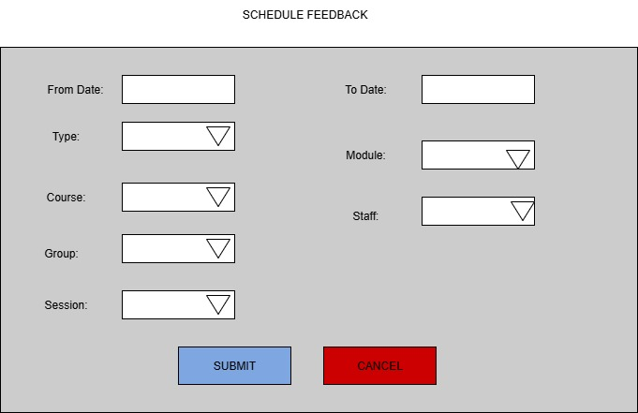

1. **Student Feedback Form**

Student Feedback Form

We design feedback form for students

Type- we can select like end module or mid module

Course- dac,dmc

Module - dot net

Staff name and session count

Admin can set the type of questions according to that we design 3 form

Type of questions

1. MCQ type

2. Discriptive questions

3. Rating

According to questions type we design 3 students feedback form

We added comment section to add any suggestions from students

Lastly students can submit or cancel the form

#1. Question Type – Mixed (MCQ, Rating, Descriptive)

2. Question Type – MCQ / Radio Button

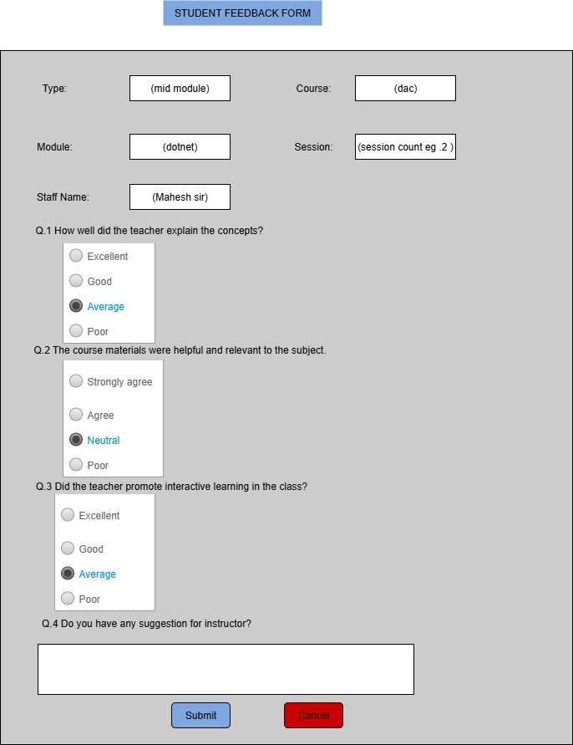

3. Question Type – Rating out of 5

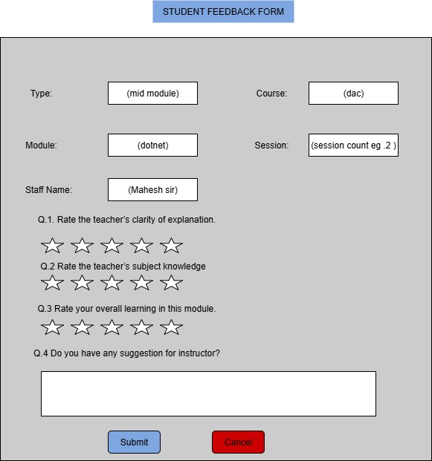

4. Question Type – Descriptive

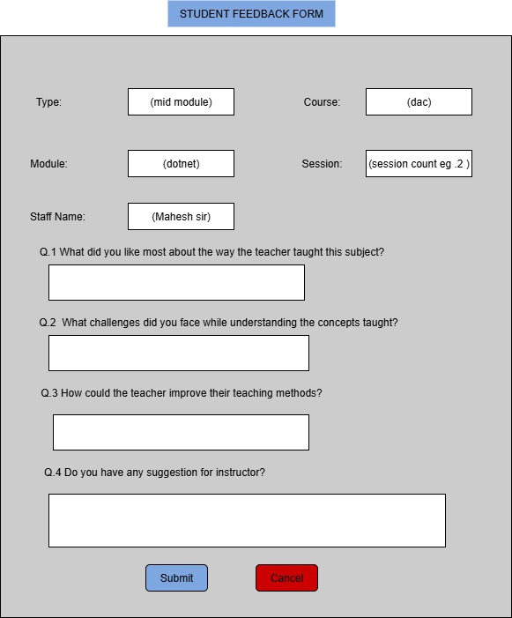

1. **Admin Dashboard Course wise Feedback**

Course wise feedback

in Course wise feedback we can select

1.course- as K-DAC-FEB-2025

2.midmodule- offline mid module theory, offline mid module lab,

3.module end - module end feedback lab,

4.infra end- if it is offline mode we can give infra end feedback

According to above selection we can give ratings to particular feedback type

we can select module name as dot net, java and if we select mid module feedback for that particular module rating will be generated and we can see it

in table similar for module end and infra end.

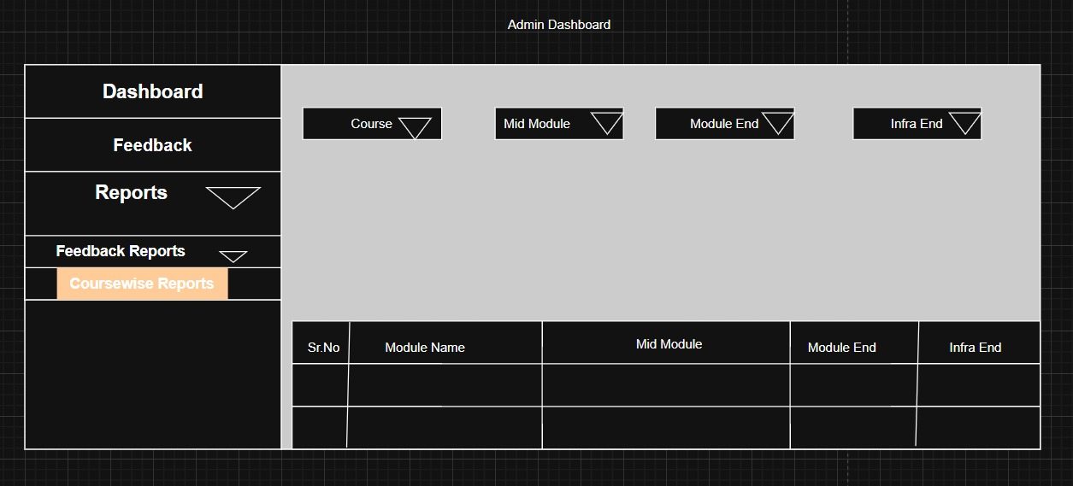

1. **Student Dashboard Feedback**

This is Student Dashboard page

PROFILE: student profile information

DASHBOARD: Brings the user back to the dashboard home view.

FEEDBACK: Dropdown menu

- PENDING: Feedback forms that the student needs to complete.

- HISTORY: Displays past feedback submit.

LOGOUT: Logs the student out of the system.

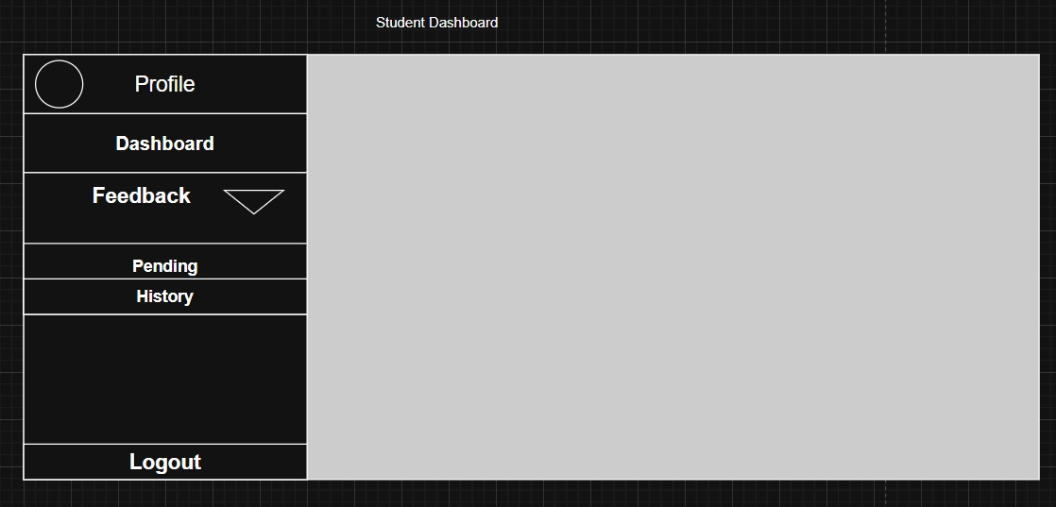

1. **Staff Dashboard Feedback’s**

staff dashboard

staff can see his/her feedback summary:

course-Mahesh sir

date

module-dot net

type of feedback-mid module

session- for eg.4

rating- 4.9

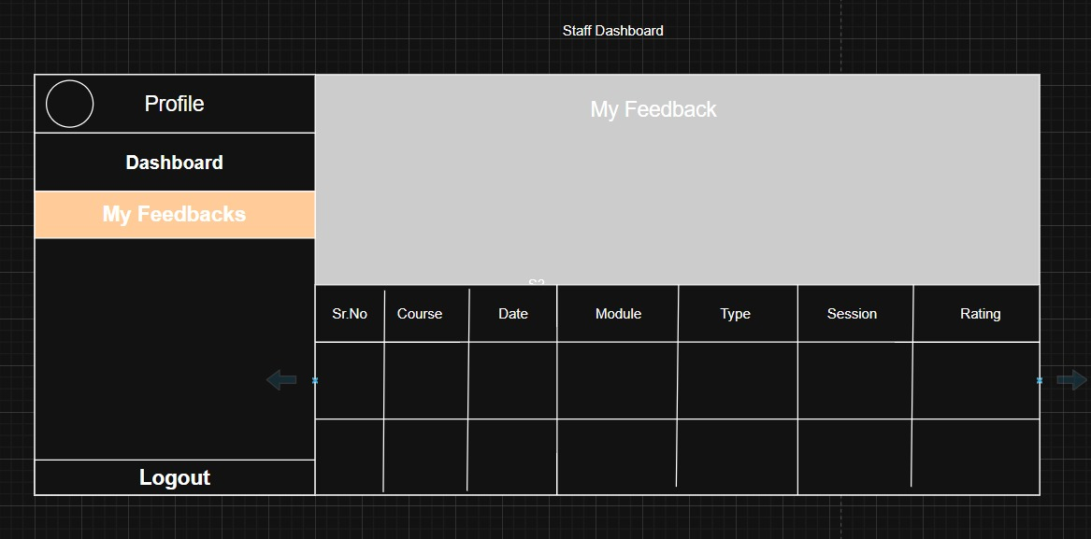

1. **Faculty Feedback Summary**

Faculty feedback summery

feedback type: mid module, end module

module: dot net, java

course : PG-DAC

staff: Mahesh sir

date: feedback visual from to date

we have given search button on click of this button we can see count of feedback submitted student and remaining student and rating according to questions.

we have given questions and according to that options are given as excellent, good ,satisfactory, unsatisfactory.

at the end we can export this summery .

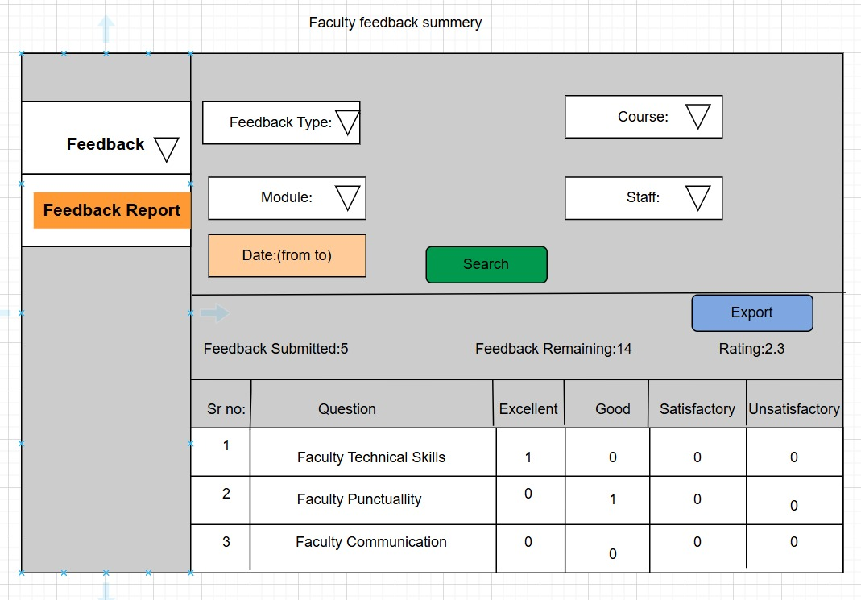

1. **Feedback Summary Per Faculty**

This is feedback summary page per Faculty.

Admin can select Course Type, Course and Course Cycle and he can select multiple Feedback Type’s based on this information he can generate report per Faculty in Candle diagram format.

